Digital Technical Specification – User Interface and native Knowledge Graph methods

Statement of Work (SoW)

Version 0.1

The SOW document or Request For Quote shall always include relevant document- and revision number though this document is a part of the Commercial contract between the parties.
If there is some information that is not relevant or missing, please, add or remove.

Contents
1 Introduction 3
1.1 Introduction 3
2 Scope 3
2.1 Scope 3
3 Limitations 3
4 Responsibilities 3
4.1 Scania Responsibilities 3
4.2 Supplier Responsibilities 4
4.3 Team Responsibilities 4
4.4 Project Organization 5
5 Working methods 5
5.1 Working Methods 5
5.2 Quality Assurance 5
5.3 Access to premises 5
6 Governance 6
7 Resource Equipment 7
Revision History 7

Introduction

Introduction
This document describes the work to be performed by Supplier to “Scania CV”, with regard to the Digital Technical Specification - User Interface and native Knowledge Graph methods related Services, including roles and responsibilities.

Scope

Scope
The request concerns a Proof of Concept done during 10 weeks to display a product-component model (Technical Specification) and use that model to visualize and answer questions on possible combinations for a certain product. Acceptance test will be carried out by Scania at the end of the period and if successful the PoC will be promoted to production after the PoC is over.
Scania’s modular production uses more than 40 000 components that are combined using more than 700 choices when building a vehicle. Each combination limits what other components you can/should choose – e.g. if you choose an electric engine you should also choose a battery and not a gas tank. In early stages of vehicle design/development, the limitations and possible choices are described in a set of word-documents called Technical Specification. As they are created using word, it is a highly manual task to create and maintain, but also to interpret and use, this information.
To increase both efficiency and quality, a digital solution has been suggested that uses a knowledge graph where the components are grouped into families and the relationship between nodes and families are described as relations. This new solution is called Digital Technical Specification (DTS).
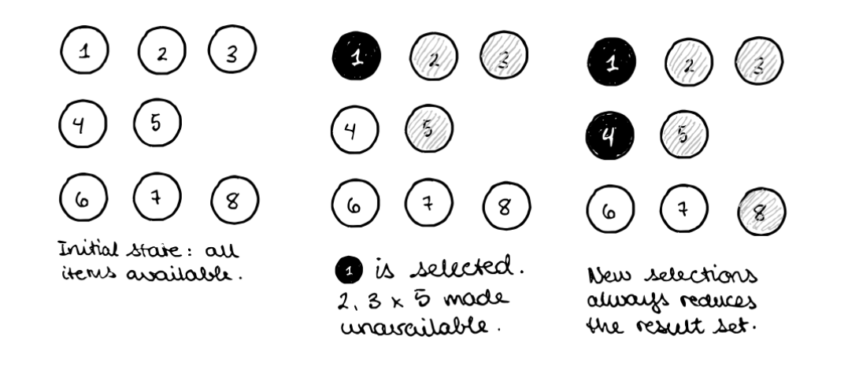
DTS uses logic in a custom built application to interpret the graph and display the next possible choices. To further enhance the solution we want to explore how the same result can be achieved using Knowledge Graph native methods such as OWL and SHACL, instead of application logic.
Differently phrased, the problem is to reproduce a decision tree and perform automatic valid permutations directly in the knowledge graph itself, based on previous choices. Our hypothesis is that using Web Ontology Language (OWL) Restrictions, in combination with descriptive Shapes Constraint Language (SHACL) shapes, will allow us to model all permutations of configurations of a vehicle.
The resulting work should in every way behave as the existing DTS solution, both for functional and non-functional requirements. A subset of data will be made available for the Supplier to work with in the original form (word-documents) – and the solution architect for the ongoing DTS will be available for questions and input during the process.
The resulting work will fully be the property of Scania.
Delivery:
- A working solution built using Knowledge Graph native methods that behaves as the existing solution where logic is coded into the application (as described above).
- Documentation of the solution so that it can be re-implemented by another team into a productive solution.

Limitations
Limitations e.g. of technical- administrative or resource-oriented nature, locations, availability of facilities Services are as follows:
- the result of this work is to be considered a proof of concept (PoC), meaning that it will not be moved to production or handed over to maintenance. In all other aspects it should work as a real solution, and must not use fake data or mock-up functions. (It should however be possible to use the PoC as a template for developing the Digital Technical Specification solution with Knowledge Graph native methods)
- this PoC is limited in time to 10 weeks

Responsibilities

Scania Responsibilities
Scania shall:
- do acceptance test and/or Approve delivery without unreasonable delay.
- act on Suppliers reasonable request, provide feedback without unreasonable delay.
- provide information about legal and regulatory requirements relevant to the project.
- provide the technical environment that is relevant to the project.

Supplier Responsibilities

Expectations:
- Have a professional approach when interact with Scania and Scania Personnel. Examples: No unnecessary contacts. Learn. Do not ask same question several times. People who approach Scania should have right competence.
- Proactive. There should not be any surprises for Scania. If there are unexpected impacts on plans and the operation. Scania shall be informed on the casa and presented the action taken to minimize the impact.
- The supplier should specify what kind of contact/support/interaction they need and when.

Supplier shall:
- Secure the capacity and right competence in the teams relevant to the assignment.
- Ensure that the teams have the right conditions and understanding to fulfill the expectations from Scania.
- if there are any activities that is not clearly specified as out of scope, the supplier must take the full responsibility for these activities and costs.

Team Responsibilities
The teams shall:
- Understand the requirements presented
- Plan the work and delivery according to the requirements.
- Present the suggested solution before starting development to get approval.
- Synchronize with systems and other teams when/if there are dependencies
- Be responsible to secure the quality of the deliveries. This means to plan needed reviews and verification for each delivery.
- Be proactive. Highlight problems with deliveries early on. E.g. delays, architectural issues and coordination. It is expected that actions are taken to minimize negative impacts.

Organization
The development team (from the supplier) could consist of one Semantic Expert leading the team and being the main contact between Scania and the Supplier, one solution architect knowledgeable in the tools and methods (Stardog, AWS Neptune, Protégé, Hermit, etc) and one or more developers.
Scania will be able to change people that interact with Scania Personnel if they do not fulfil Scania’s expectations.

Working methods

Working Methods
The working methods, e.g. implementation method and strategy, are as follows;
- Work to be carried out in an agile way, with two weeks sprints. Meaning that functionality is delivered in steps and each sprint has a defined scope.
- Bi-weekly planning meetings to plan for the next coming sprint
- Bi-weekly retrospectives to reflect together with product owners and developers at Scania and together improve the way of working.

Quality Assurance
Quality assurance e.g. test plan, test cases, test data, test execution, integration test, user acceptance test, performance and stress test shall be as follows:
Scania
- Test the delivered functionality to ensure it aligns with expectations

Team. Supplier
- Build automated tests for the code (unit, regression & integration)
- Ensure that the delivered solution behaves as the existing PoC

Access to premises
If needed and agreed with Scania, access to premises is according to Scania ISEC (IT Security Code of Conduct).
Information about the Security rules regarding project result, material, responsibilities, etc is described and agreed upon in the general Contract.

Governance
Meeting structure

Sprint meetings
Purpose: Decide on the Scope for the coming sprint. Follow up previous sprint (can be separate meeting)
When: Each sprint (bi-weekly)
Participants:
- Scania Product owner (Approve the content for the sprint)
- Supplier Team representative (present the sprint plan)
- DTS representative (Requirement owner and connection to the DTS project)

Content
- Sprint scope
- Sprint result ( can be separate meeting)

Service Levels
n/a

KPI
n/a

Resource Equipment
The following Parties are responsible for needed resources e.g. equipment, material, premises as follows:
Scania:
- Access to necessary software and applications

Supplier:
- Computer
- Phone

Revision History

Date | Version | Description | Author
2022-04-29 | 0.1 | First draft | Jan Guhrés
 |  | Initiation of contract

